Terra – Algorithm & Data Processing Spec v1.0 Addendum
This addendum provides (1) explicit default parameters, (2) a step-by-step pipeline sequence, and (3) test cases and acceptance criteria for Phase 1 modules. It complements the main Algorithm & Data Processing Specification.

1. Default Parameters (Proposed Baseline)
All parameters are version-controlled. Defaults below are starting points and may be tuned with documented rationale.
Module | Parameter | Default | Notes
Sentinel-2 | Product level | L2A surface reflectance | Use SCL when available
Cloud masking | Mask classes | SCL cloud+shadow+cirrus | Fallback: QA60/cloud-prob
Plot validity | Min valid pixels | 20% | Below this: ‘insufficient clear-sky’
NDVI | Bands | B8 (NIR), B4 (Red) | Clip to [-1,1]; denom=0 → NoData
EVI (opt) | Constants | G=2.5, C1=6, C2=7.5, L=1 | Bands: B8,B4,B2
Compositing | Operator | Median | Alternative percentile must be versioned
Compositing | Temporal window | Calendar month | Timezone set for reporting
Heterogeneity | Window size | 5×5 pixels | Configurable; default ~50m
Change detection | ΔMoM threshold | -0.10 NDVI | Flag only if valid pixels ok
Change detection | ΔYoY threshold | -0.10 NDVI | Requires t-12 available
Fire tagging | Buffer distance | 1 km | Store proximity + confidence
Aggregation | Plot summary | Median + IQR | Robust to outliers
Aggregation | Zone rollup | Area-weighted medians | Store density/depth
Confidence (Tier 1) | Inputs | valid pixels, depth, consistency | 0–1 score + band
Publishing | Update cadence | Monthly | Push ‘Monthly Brief’

2. Pipeline Sequence (Phase 1)
The following sequence is the authoritative order of operations for Phase 1 processing.
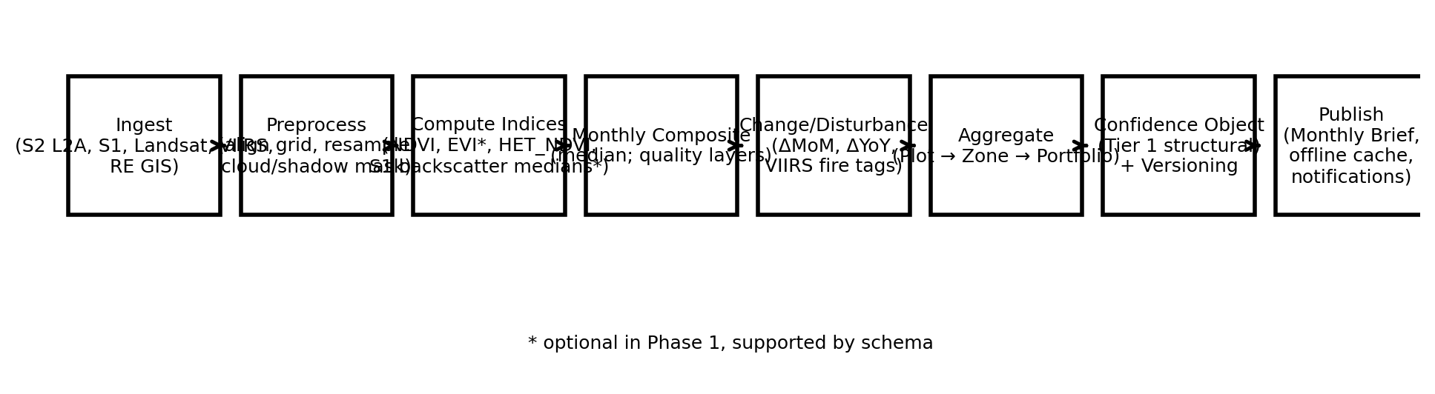
1) Ingest sources for the target month (Sentinel-2 required; others optional).
2) Spatial normalisation: align grids, resample as needed, clip to AOI/plots.
3) Apply cloud/shadow masking and compute ValidPixelFraction.
4) Compute per-scene indices (NDVI; EVI optional) and per-scene structural proxies.
5) Monthly composite: median per pixel; generate quality layers.
6) Compute change signals (ΔMoM, ΔYoY where available).
7) Disturbance context: apply VIIRS fire tags and store events.
8) Aggregate to plot summaries; roll up to zone and portfolio scaffolding.
9) Compute Tier 1 confidence object from coverage/depth/consistency.
10) Persist outputs with method_version + parameters; publish Monthly Brief + push notifications.

3. Test Cases & Acceptance Criteria
Acceptance criteria are written to be verifiable by Emergent during implementation.
Module | Test Case | Acceptance Criteria
NDVI calculation | Given a sample pixel with known Red and NIR reflectance values, NDVI matches formula output within ±1e-6. Denominator=0 returns NoData. | Pass if unit tests cover normal, denom=0, and clipping bounds.
Cloud masking | Pixels marked cloud/shadow in SCL are excluded from composites; ValidPixelFraction reflects remaining pixels. | Pass if masked pixels do not contribute to NDVI_monthly and coverage metric is correct.
Monthly compositing | For a pixel with N clear observations, composite equals median of observations (or documented operator). | Pass if reproducible across runs with same inputs and parameters.
Plot validity gate | If ValidPixelFraction < 20% for a plot-month, Monthly Brief is generated with ‘insufficient clear-sky’ status and no misleading trend arrow. | Pass if UI/API flags quality state and suppresses unreliable insights.
Heterogeneity metric | HET_NDVI output equals variance of NDVI within the defined window; changing window size changes result predictably. | Pass if window-size parameter is honoured and validated by test raster.
Change detection | ΔMoM and ΔYoY are computed correctly; disturbance flags only trigger when validity gate passed. | Pass if flags never trigger when ValidPixelFraction below threshold.
Fire tagging | VIIRS detections within 1 km buffer create a fire event record with date and confidence; plot-month marked as ‘fire context’. | Pass if events are stored and displayed as context, not automatically as degradation.
Aggregation rollups | Plot summaries use median + IQR; zone rollup uses area-weighted medians; portfolio scaffolding stores membership without credit logic. | Pass if aggregation outputs match reference calculations for test set.
Confidence object | Confidence_score is produced for every plot-month with stored inputs; increases with greater valid pixels and time depth. | Pass if confidence is monotonic with synthetic test inputs and stored for audit.
Versioning/reproducibility | Re-running the pipeline with identical inputs and method_version produces identical outputs; changing a parameter increments method_version and preserves prior results. | Pass if outputs are traceable and reproducible under both versions.
Offline cache & notifications | Latest Monthly Brief is cached locally; user receives monthly push notification; offline viewing works without connectivity. | Pass if QA checklist confirms offline open + queued sync + push delivery in staging.

4. Notes on Canopy Height
Phase 1 does not claim canopy height from Sentinel-2/Sentinel-1 directly. Any canopy height product requires separate data sources (e.g., LiDAR/photogrammetry) and will be specified in a future Tier 3 document. In Phase 1, the app should label outputs as ‘structural proxies’.

